**Ad Hoc Reporting How-To Documentation for MCPHD**

By: Christine Haas

Civic Technologist, christine@haasCo.net

**Creating a new report:**

1. Look at the report structure and decide if it shall be a complex report with a main section and sub-report(s) or a simple report (containing no sub-reports).



1. This example is based on a complex report with a Main section and several sub-reports.
2. Design a new report, choosing your views and how they will join via the DataSource menu item.
   1. The views and relationships chosen below are based on the Main section of this report.
   2. My preference is to include the V_RECORD view in most reports, as the Record ID (permit/case/license #) is a primary field in the Civic Platform DB Schema. You will find that ***joining to*** the V_RECORD view on the RECORD_ID is customary practice in report development.

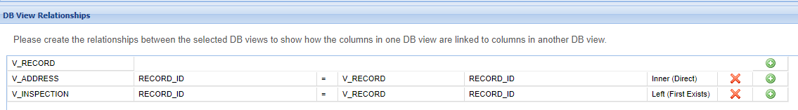

1. Add fields to your report.
   1. By default, the Description (or alias) will be the same as the Field name without the underscore. My preference is to use a more descriptive alias. Any integer field will default to the Format of 0,000. To change this, simply click on the Format drop-down and change it to “…” (no format).
   2. Date fields have additional format options as well. Click the drop-down to change formatting.
   3. Once you Group on a field (INSPECTOR_USERID), all fields automatically group.
   4. This report **V**isually **G**roups and sorts by Inspector and Street Number, thus the checkboxes **Sort** and **VG** are checked for each of the two fields INSPECTOR_USERID and STREET_NBR.
   5. Order the Visual Grouping/Sorting so that the top field takes precedence.

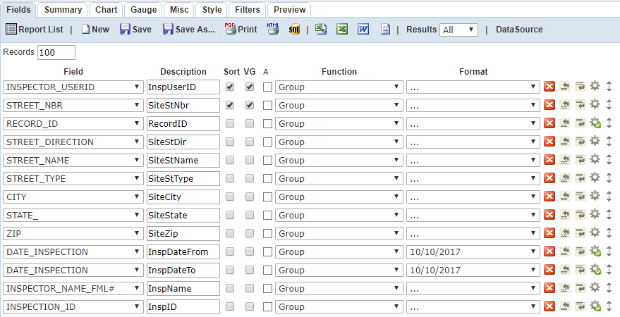

1. Save your report.
   1. My preference is to leave ***no*** white space in either the Report Name or the Category.

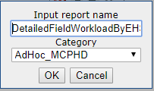

1. Preview your report ***before*** designing it to verify your data and joins are correct. You may need to return to the DataSource menu to make modifications, such as a join change or selecting Distinct, for example. You may also need to visually group and/or sort the data, as well as apply filters (field is not blank, for example).
   1. In this report, the DATE_INSPECTION (the inspection date/time stamp) will occur within a date range, therefore you may want to filter ***out*** records without inspections.
   2. This report will also require that an inspector ID be chosen from a drop-down list of current inspectors in the agency.
   3. Ad Hoc report filters default to OR, therefore the Filter Logic has been added to require that all filters (1 **AND** 2 **AND** 3 **AND** 4 **AND** 5 **AND** 6) apply.
   4. Notice that the Parameter checkbox is checked only for the date range (1 AND 2) and the Inspector UserID (3); the 4th through 6th filters are unchecked. Ad Hoc will check the Param checkbox by default, so make certain to uncheck filters that are NOT parameters in your report.
   5. I often ***do not check*** the Require checkbox (unchecked by default). My preference is to Require the parameter(s) when configuring them in Report Manager.
   6. Test your parameters in Ad Hoc by entering static values (then removing any static parameter values upon final Save).

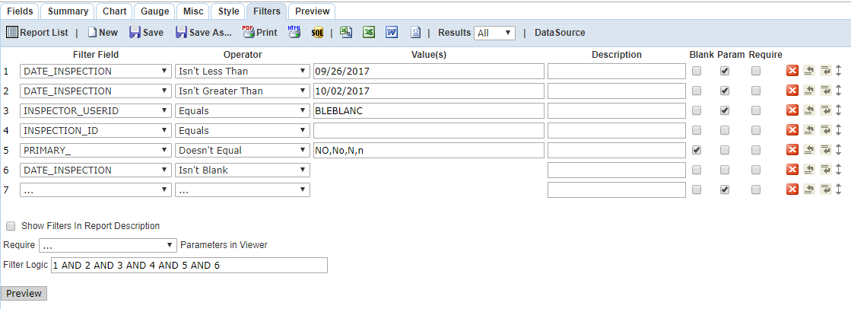

1. Thus far the report previews in tabular format with the Agency logo at top left (default). The change the position of the logo, go to the Misc tab and click on the Report Header Image Justification checkbox to change it from **L**eft to **M**iddle or **R**ight or blank (empty checkbox).
   1. Note that once a report is designed with code (HTML with potential of embedding JavaScript and CSS), the Agency logo will not show. To add an image (logo, electronic signature) the Agency must provide a URL to the image path. Very frequently, this image is found on an Agency’s public web site, from which the path may be obtained and embedded in the report code (ie, <http://www.hhcorp.org/hhc/images/MCPHD.png>)
   2. The HTML code below is an example of how to embed the MCPHD logo into a ***designed*** Ad Hoc report.

<table class="mce-item-table">

<tbody>

<tr>

<td width="312" rowspan="1">

<p align="center">

<img width="100" height="100" align="left" alt="" src="http://www.hhcorp.org/hhc/images/MCPHD.png"

data-mce-src="http://www.hhcorp.org/hhc/images/MCPHD.png">

</p>

</td>

</tr>

</tbody>

</table>

* 1. Below is the report in tabular format only, no designing has been added; static data removed.

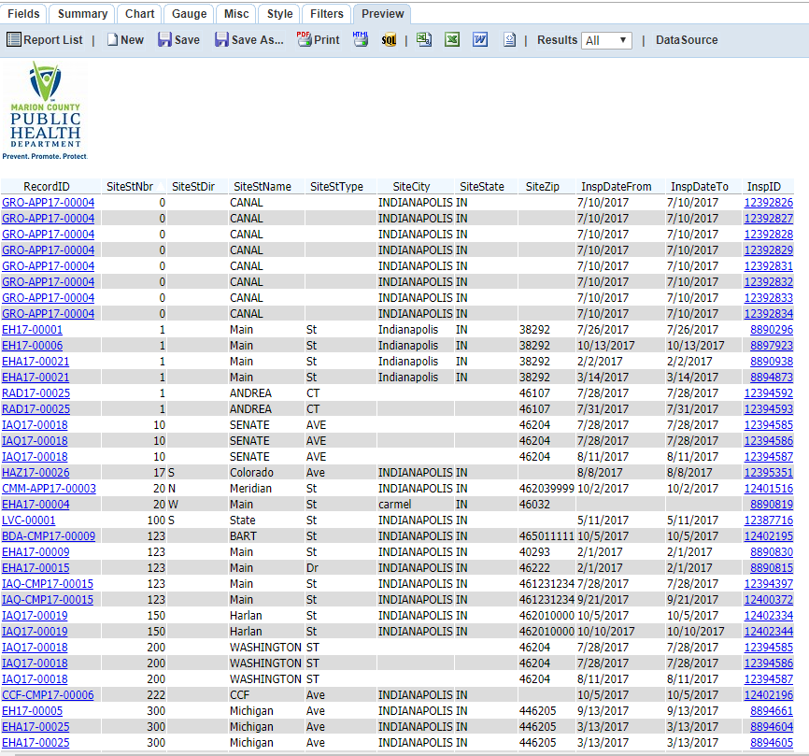

**Designing the new report:**

1. This report has a distinct report header, including the Agency Name – Department, Report Title, Inspector Name, and an Inspection Date Range.
2. Since this information does not repeat on each page, utilize the Misc tab to enter your Report Header.
   1. Notice that the field names are ***not*** the field aliases (Description) but the actual FIELD_NAME.

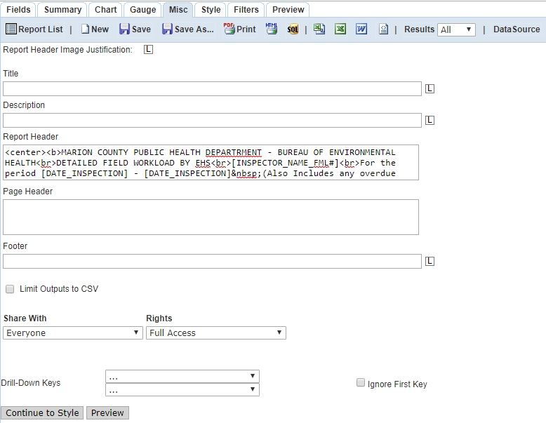

<center><b>MARION COUNTY PUBLIC HEALTH DEPARTRMENT - BUREAU OF ENVIRONMENTAL HEALTH<br>DETAILED FIELD WORKLOAD BY EHS<br>[INSPECTOR_NAME_FML#]<br>For the period [DATE_INSPECTION] - [DATE_INSPECTION]&nbsp;(Also Includes any overdue inspections)</b></center><br><br>

1. Since this report lists the Inspector’s inspection activity within the date range by site address, the main report code is currently quite simple.

<p>

</p>

<br>

<br>

<u>

<b>[SiteStNbr]&nbsp;[SiteStDir]&nbsp;[SiteStName]&nbsp;[SiteStType]&nbsp;[SiteCity]&nbsp;

[SiteState]&nbsp;[SiteZip]

</b>

</u>

<p>

1. Preview mode shows it as such, thus far. Remember, no sub-reports have been added yet.

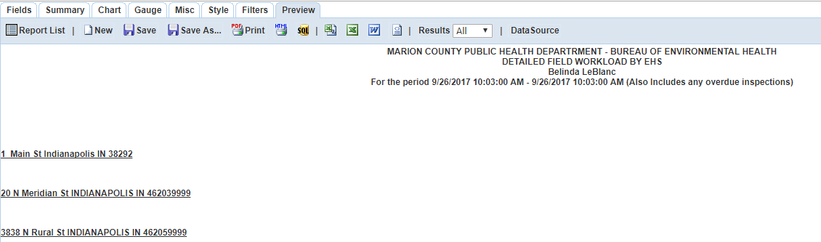

1. To see the report in PDF format, simply click on the PDF icon, wait for the report to generate the file, then view it.
   1. Ad Hoc reporting date ranges are not as sophisticated as they are in Crystal. Even though the report range is from 9/26/2-17 – 10/02/2017, it displays the date range as FromDate – FromDate, yet includes ALL data that does indeed fall between the actual static date range chosen for testing.

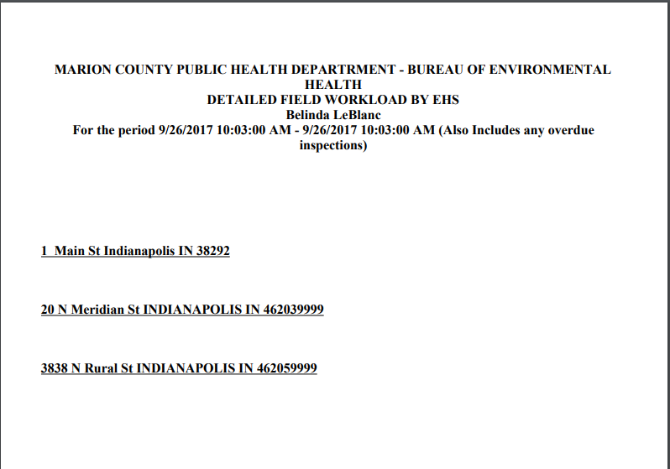

**Adding sub-reports to your Main Report:**

1. Each sub-report must contain a link to the main report. Since this report focuses on **Inspections**, regardless of record, V_INSPECTION.INSPECTION_ID is being used as the link.
   1. Make it a habit of Saving your sub-report with a useful name (for re-purposing in other reports).
2. Rules for sub-reports:
   1. In the Misc tab you must select a drill-down key. In this report example, it is INSPECTION_ID (***not*** RECORD_ID)

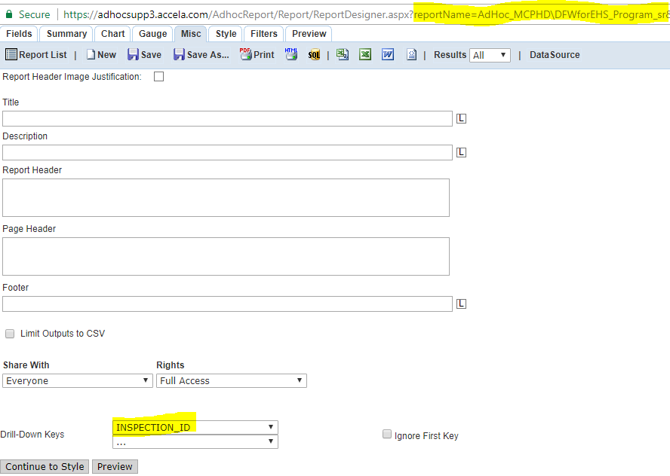

* 1. Include the drill-down key in your filter. Preference is to include all parameters that are in the Main report as well as all filters (replicate Main).
  2. Please note that static values have been added for testing of this report and presentation of this document. They will be removed before configuring this report in Report Manager.

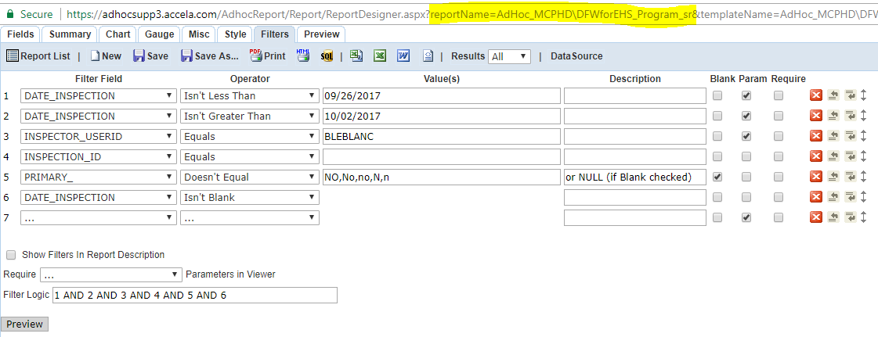

1. Design contains the Program section of this report only; visually viewed and coded as such:

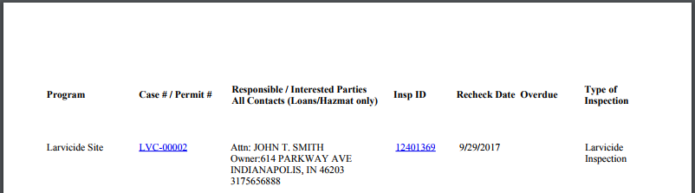

<p>

<br>

</p>

<table width="962" class="mce-item-table" style="height: 32px;" data-mce-style="height: 32px;">

<tbody>

<tr>

<td width="150">

<b>

Program

</b>

</td>

<td width="150">

<b>

Case # / Permit #

</b>

</td>

<td width="264">

<b>

Responsible / Interested Parties

</b>

<br>

<b>

All Contacts (Loans/Hazmat only)

</b>

</td>

<td width="100">

<b>

Insp ID

</b>

</td>

<td width="100">

<b>

Recheck Date

</b>

</td>

<td width="100">

<b>

Overdue

</b>

</td>

<td width="100">

<b>

Type of Inspection

</b>

</td>

</tr>

</tbody>

</table>

<p>

<br>

</p>

<table width="962" class="mce-item-table" style="height: 46px;" data-mce-style="height: 46px;"

data-mce-selected="1">

<tbody>

<tr>

<td valign="top" width="150">

[RECORD_TYPE]

</td>

<td valign="top" width="150">

[RECORD ID]

</td>

<td valign="top" width="264">

Attn: [NAME_FULL]

<br>

Owner:[ADDRESS_LINE1]

<br>

[ADDRESS_CITY],&nbsp;[ADDRESS_STATE]&nbsp;[ADDRESS_ZIP]

<br>

[PHONE]

</td>

<td valign="top" width="100">

[InspID]

</td>

<td valign="top" width="100">

[InspRecheckDate]

<br>

</td>

<td valign="top" width="100">

<br>

</td>

<td valign="top" width="100">

[INSPECTION_TYPE]

<br>

</td>

</tr>

</tbody>

</table>

1. Link the sub-report to the Main report.
   1. Remove all static values from the sub-report; leave them in the Main report for testing at this point in time.
   2. Save the sub-report after removing the static field values.
   3. Edit the Main report
      1. Add the field INSPECTION_ID from the V_INSPECTION view to the Fields tab
      2. Use a useful name in the Description to indicate this is a sub-report (ie, DFWforEHS_Program)
      3. Click on the Advanced Properties “wheel” icon for the newly added INSPECTION_ID field.
      4. Navigate to the sub-report
      5. Select the Drill-Down Style (Embedded in this example) and click OK.

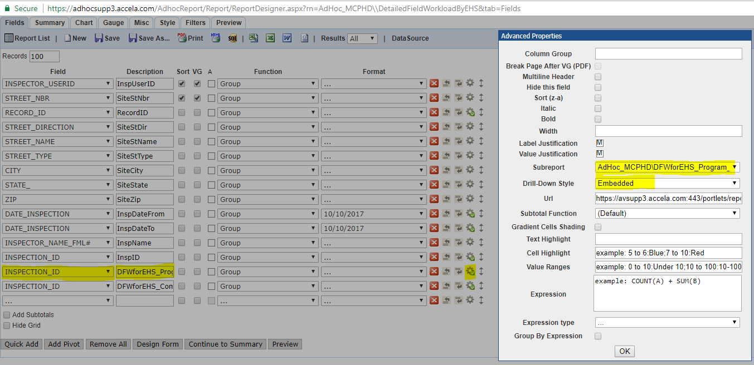

1. Add the alias (Description name) to the Main Report field via Field / Design Form.

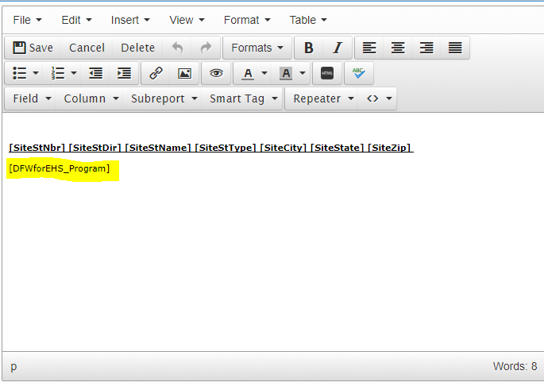

1. Our Main report returns the following data via Preview mode.

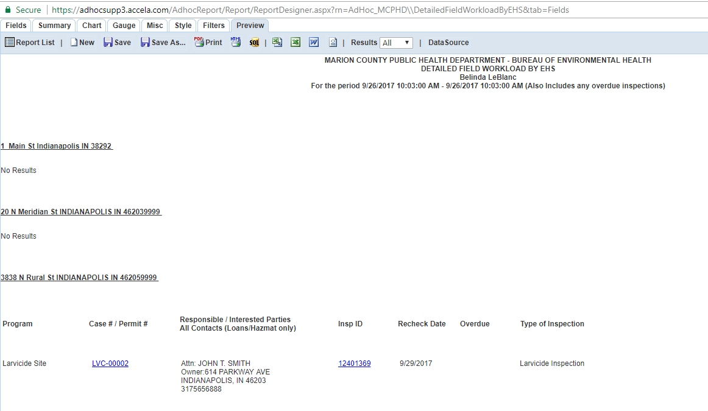

1. Add the remaining sub-reports based on additional links to the INSPECTION_ID field.

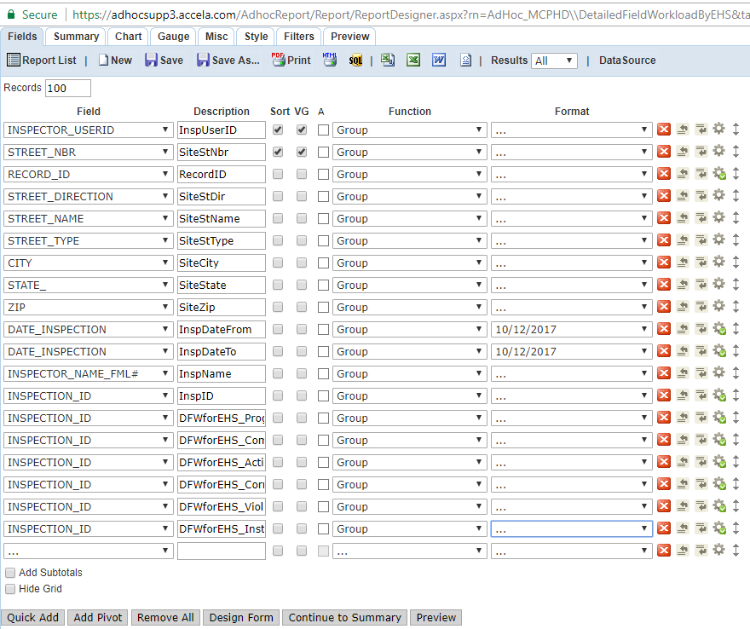

1. Add each sub-report alias (Description name) to the Main Report field via Field / Design Form, Save the Design and Save the report.

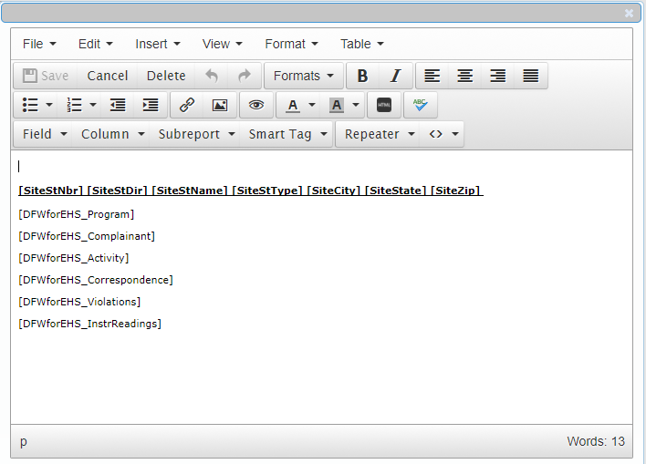

1. Our Main report now returns the following data via Preview mode (remember that static parameter values have been added to test the report thus far).

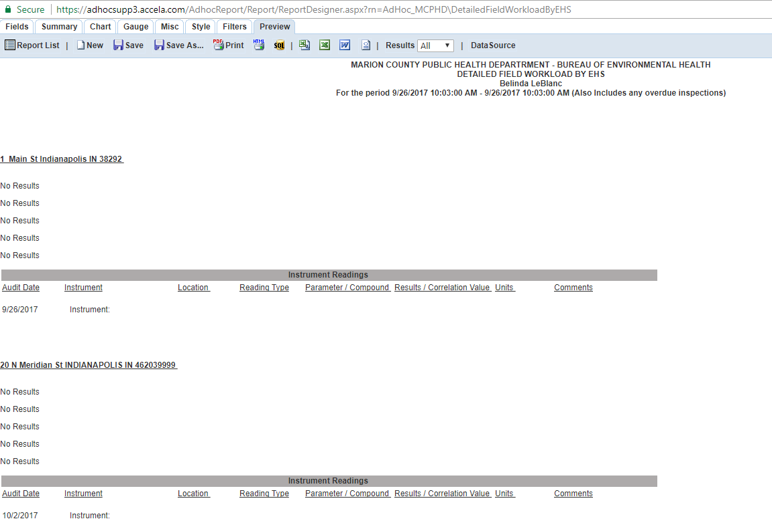

1. “No Results” displays where there is no data returned for the sub-reports. To know which sub-report is returning “No Results”, extract the code that defines the sub-report header and add it to the Main report.
2. Open each sub-report and go to its’ Design View, then click the HTML icon to access the source code.

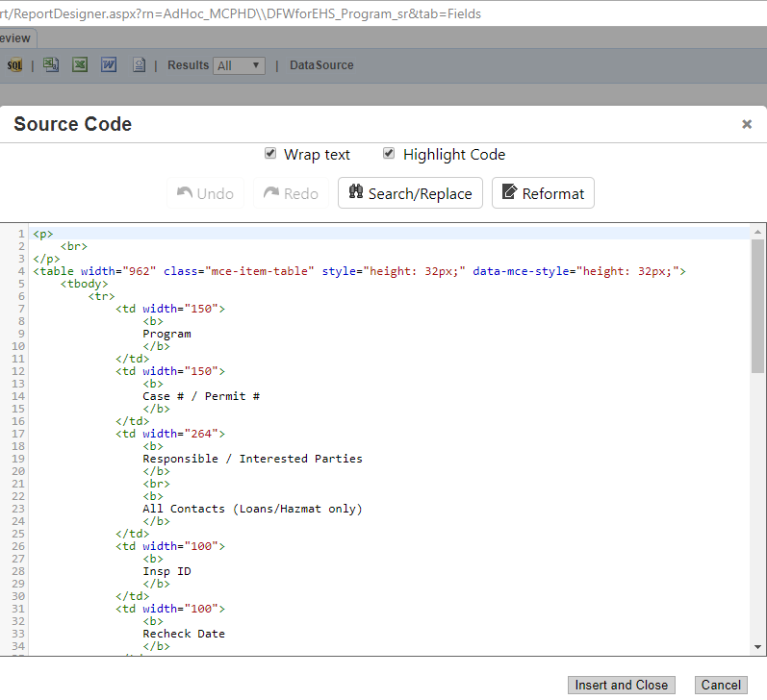

1. Copy the HTML5 source code the Notepad ++ (or your favorite editor), then Cancel out of the source code and the Design.

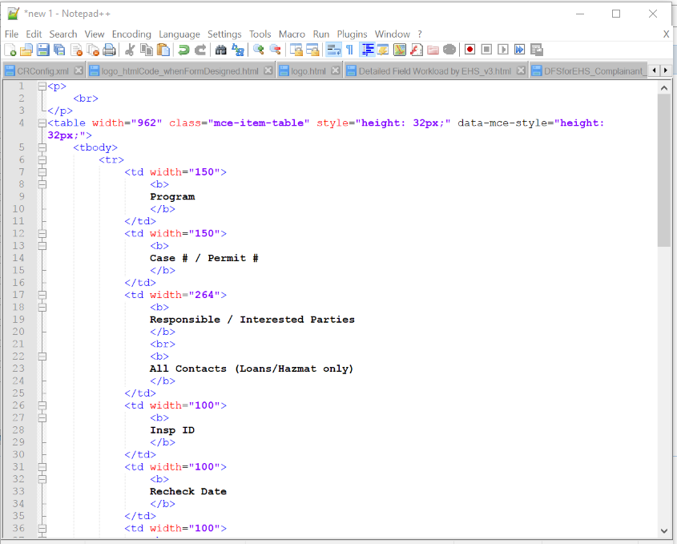

1. Extract only the table code that defines the sub-report and its’ column headers.

<table width="962" class="mce-item-table" style="height: 32px;" data-mce-style="height: 32px;">

<tbody>

<tr>

<td width="150">

<b>

Program

</b>

</td>

<td width="150">

<b>

Case # / Permit #

</b>

</td>

<td width="264">

<b>

Responsible / Interested Parties

</b>

<br>

<b>

All Contacts (Loans/Hazmat only)

</b>

</td>

<td width="100">

<b>

Insp ID

</b>

</td>

<td width="100">

<b>

Recheck Date

</b>

</td>

<td width="100">

<b>

Overdue

</b>

</td>

<td width="100">

<b>

Type of Inspection

</b>

</td>

</tr>

</tbody>

</table>

1. Enter this code into the Main Report ***before*** the corresponding sub-report field.

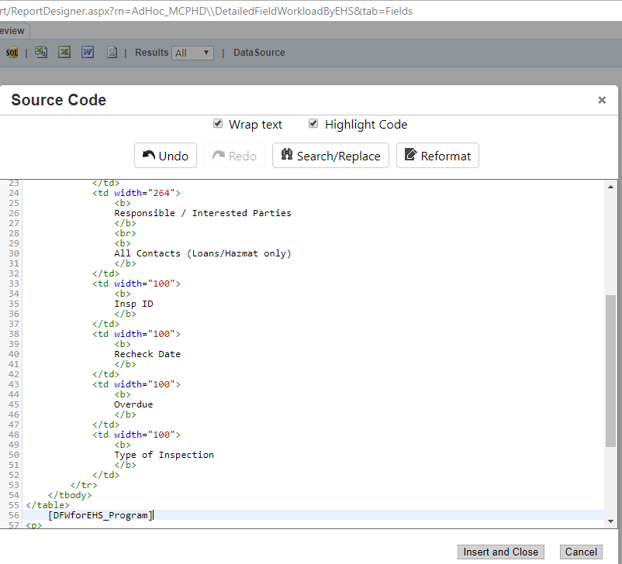

1. Insert and Close the Source Code window, then Save the Design and Save the Main Report.

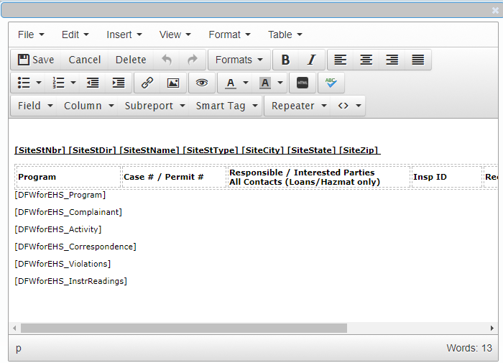

1. Repeat for each sub-report.

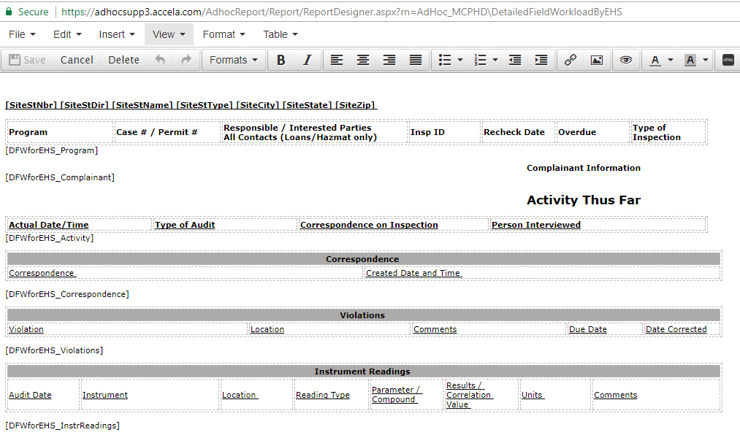

1. My preference is to copy the sub-report header code into the Main report before block commenting the code from each of the sub-reports. This allows me to visually code and preview the source code table widths (header, data fields) within each sub-report to determine correct width adjustments.

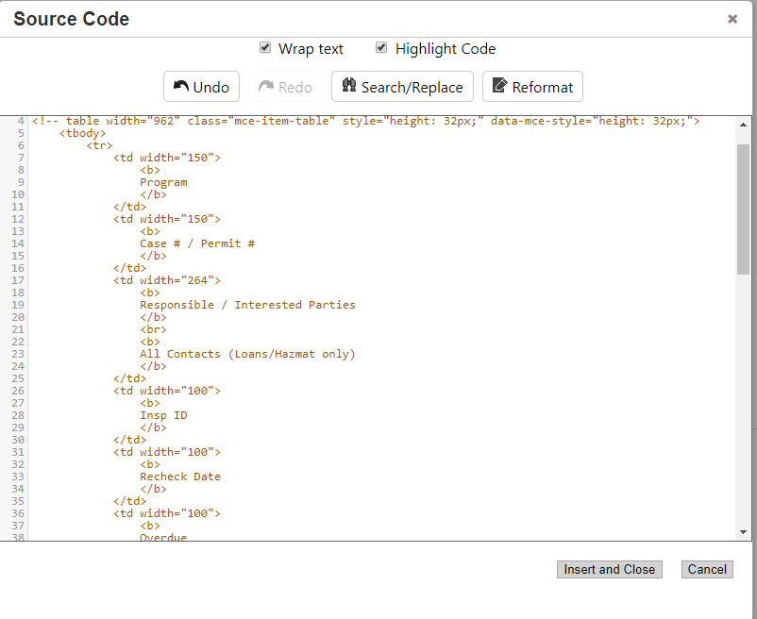

1. After block commenting the header code from each sub-report, the Main report is now ready for testing. Below is a snippet of a Site Address that contains quite a bit of data, based on our static parameter values.

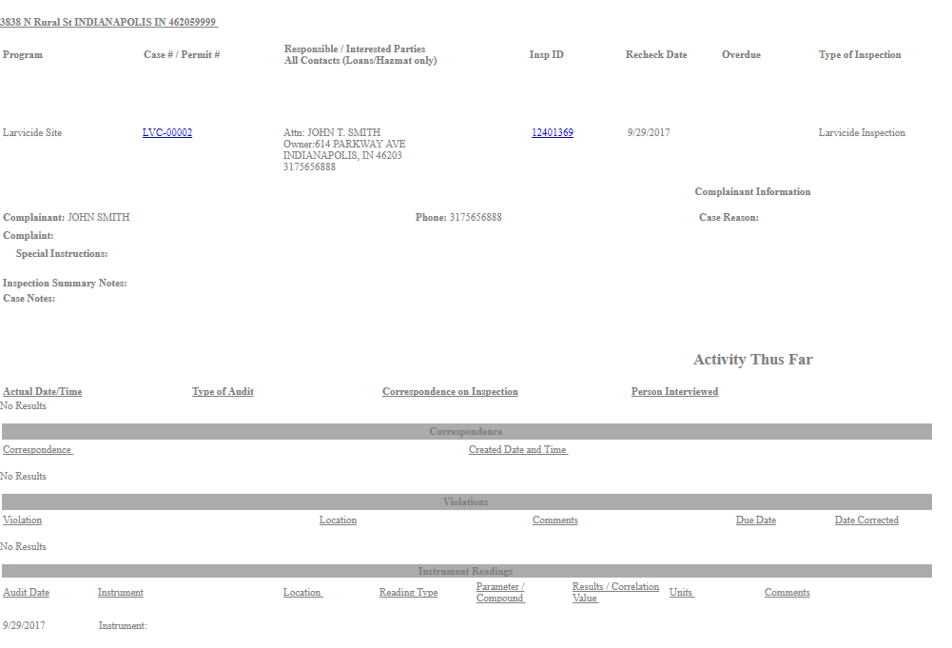

The PDF output: 

1. The static parameter values have been removed from the Main Report (I also verify that no static parameter values are in any of the sub-reports).
2. We are now ready to configure the report in Report Manager.

**Configuring an Ad Hoc report in Report Manager:**

1. Click on the Gear icon and select the Administration link.

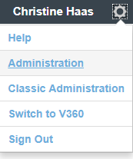

1. Expand the Report option and select the Report Manager link.

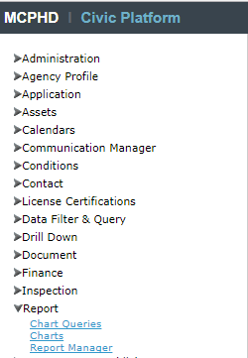

1. Expand Reports by Category, then expand Ad Hoc Reports.

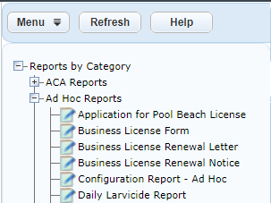

1. Right-click on the Ad Hoc Reports category and select New Report.

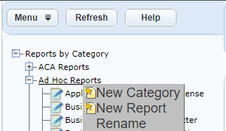

1. Enter the Name of the Report, then select the Category and Output Format. The Process Service to select is Ad-hoc Report Service. This allows for the correct list of reports, by type, to display when you click the list icon to the right of the Report Link.

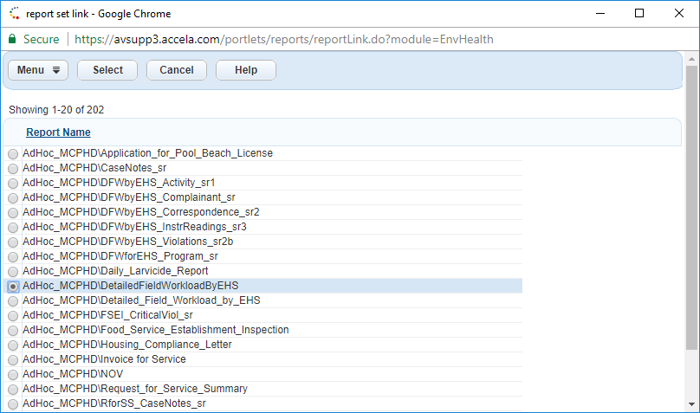

1. Include the report on Report Portlet “Reports 1” by placing a checkmark in its’ checkbox. My preference is to add the report link to the Description text box and add any other notes as well. Upon completing the configuration on the Report Detail tab, your report is configured thus far.

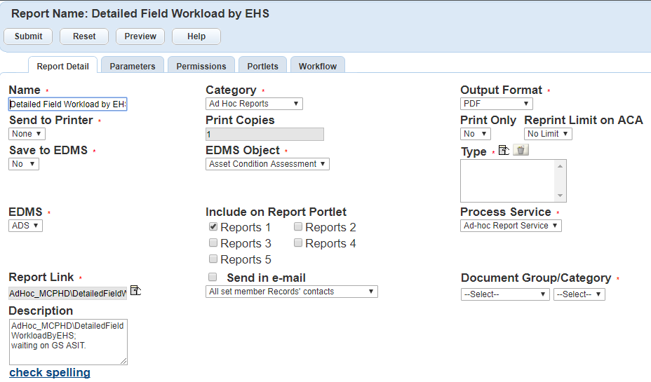

1. Be sure to save the Report Detail configuration by clicking the **Submit** button ***before*** configuring the Parameters. Look for “Updated successfully.” upon your Submit.
2. Our Ad Hoc report has three parameters: Due Date Before (DATE_INSPECTION is not less than), Due Date After (DATE_INSPECTION is not greater than), and ***one*** Inspector (INSPECTOR_USERID equals).
   1. Click the New button and enter the following values:
      1. Name – a descriptive name that the user running the report will understand.
      2. Type – this parameter is a date parameter, select Date from the drop-down list.
      3. Report Parameter Name – this is the ***first*** parameter in the Ad Hoc report, so it ***must*** be named **p1Value**.
      4. Required – this is a required parameter, select Yes from the drop-down list.
      5. Visible – this is not a session variable, select Yes from the drop-down list.
      6. Default Value – leave blank for date range parameters. If this were a session variable, the value would be AltID, for example (the Record/Case/License number).
      7. Display Order – this is the first parameter to display when the user is prompted for input values, so enter “10”. Some prefer to enter “1”; it is just my preference to number sequentially with “10, 20, 30…”.
   2. Click the **Submit** button to save the first Parameter configuration.

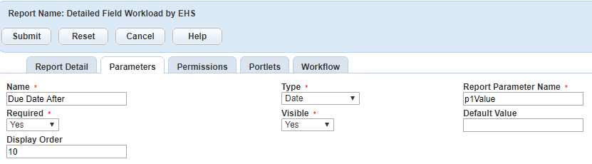

* 1. Repeat the process for the second parameter, as such:
     1. Name – Due Date Before
     2. Report Parameter Name – p2Value since it is the second parameter in the Ad Hoc report.
     3. Display Order – “20” since it is the second parameter to display to the user for input.
     4. Click **Submit** to save your parameter configuration thus far.

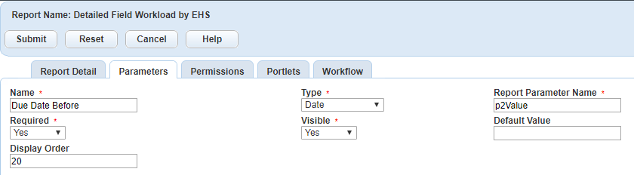

* 1. The third and last parameter requires a Drop-down list of Inspectors (by their User ID). An SQL statement is needed to create this list and plug it into the parameter configuration.
     1. Expand Settings and select Variables

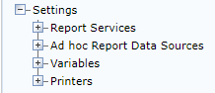

* + 1. Right-click Variables and select New Variable.

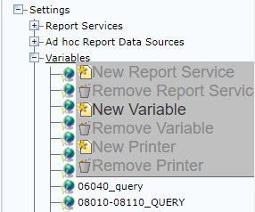

* + 1. Name your Variable using the format “AGENCY-description” (or “AGENCY_description”) and enter the SQL command in the text box. The SQL command is based not on the Ad Hoc schema, but on the Civic Platform’s Oracle DB schema. It may be helpful to look at other Variable statements to become familiar with the DB schema. You can also find schema information on Community.

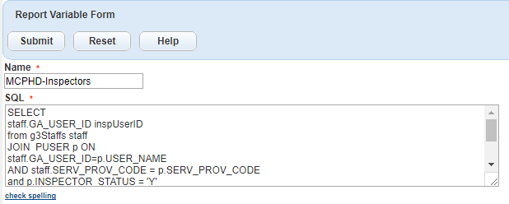

* + 1. The entire SQL command is:

SELECT

staff.GA_USER_ID inspUserID

from g3Staffs staff

JOIN PUSER p ON

staff.GA_USER_ID=p.USER_NAME

AND staff.SERV_PROV_CODE = p.SERV_PROV_CODE

and p.INSPECTOR_STATUS = 'Y'

where staff.serv_prov_code='MCPHD'

and staff.REC_STATUS='A'

and not staff.GA_LNAME in ('Administrator')

order by staff.GA_USER_ID sac

* + 1. Click **Submit** to save your Variable statement.
    2. Your 3rd parameter configuration is:

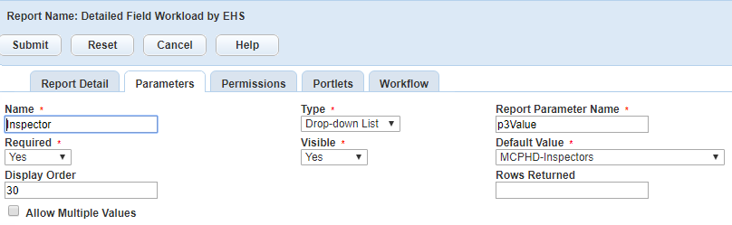

* + 1. Click **Submit** to save your 3rd parameter configuration.
  1. Your three parameters are now configured in Report Manager.

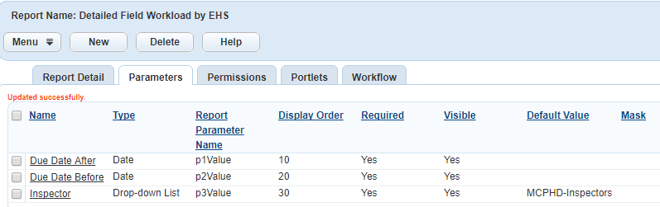

1. The final step is to add Permissions to the report.
   1. Currently the Permissions are set to the Module level (EnvHealth). If permissions need to be more granular, select the Group level by clicking Assign Group and choose, one at a time, each User Group within a specific module. Be sure to **Submit** your Permissions configuration.

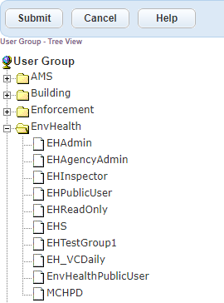

1. You can Preview the report in Report Manager by returning to the Report Detail tab. For consistency sake, I am entering the parameter values used to initially test this report in the Ad Hoc viewer. After entering parameter values, click Submit to preview the report in the Output Format configured (in this case, PDF).

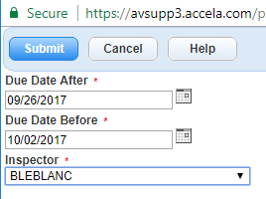

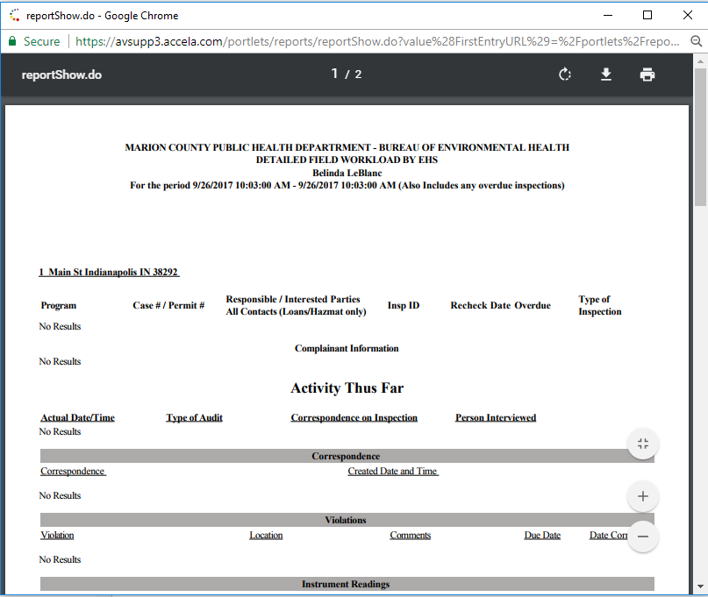

1. You can rotate, download and/or print the report via the Adobe application.
2. To run the report from the Civic Platform, Exit Administration.

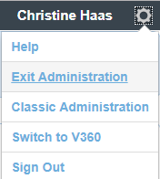

1. Select the “Report 1” tile and pin it to your start menu.

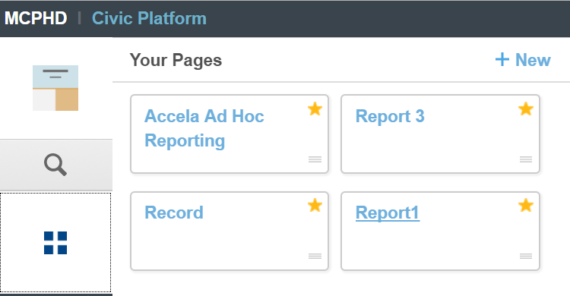

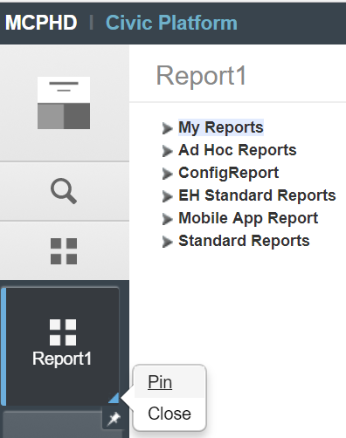

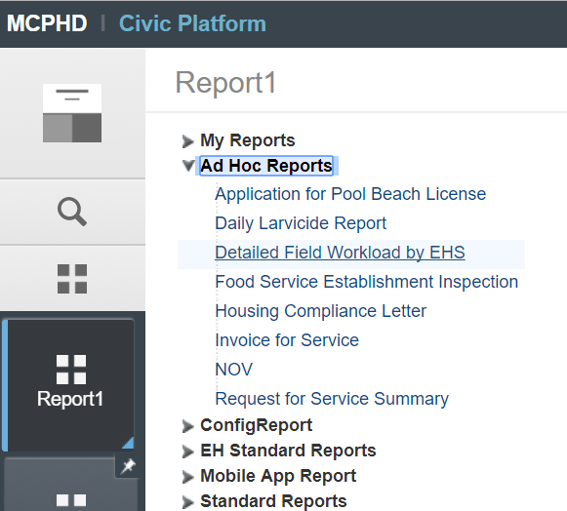

1. Select the report link and run it!

Attached are additional Ad Hoc Reporting Helper Files, courtesy of Lydia Lin, Accela Inc. I encourage you to go to Community for more updated documentation by Lydia and to join the Reports group for tips/tricks/help on Ad Hoc Reporting.

